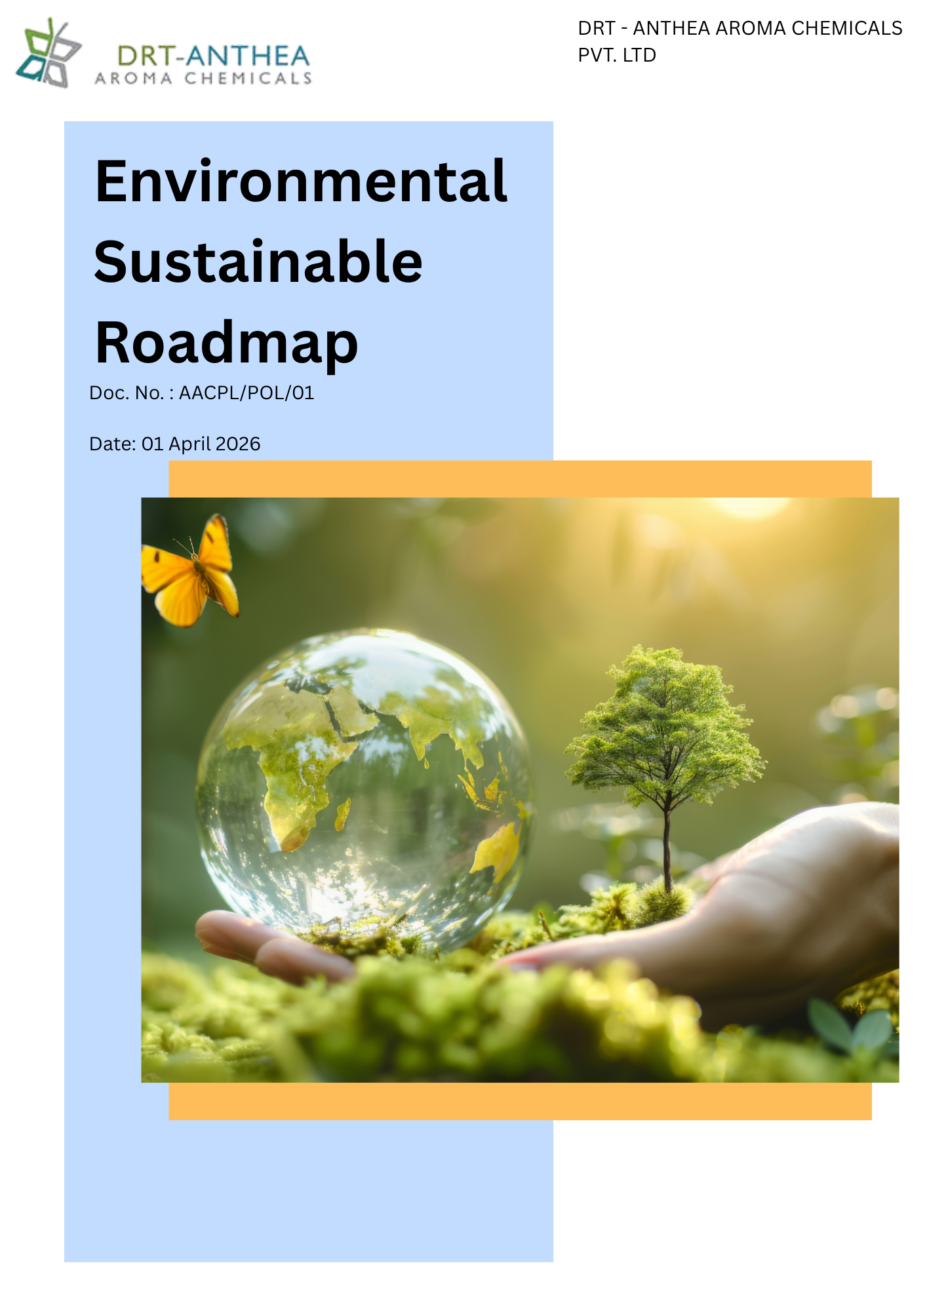
Table of Contents
List of Abbreviations 3
1. Alignment with Anthea Group Environmental Sustainability Framework 4
2. Preamble 4
3. Objective 4
4. Scope 5
5. Key Performance Areas 5
4.1 Water Stewardship 6
4.2 Energy Efficiency and Climate Change 6
4.3 Air Emissions and Pollution Prevention 6
4.4 Sustainable Management of Materials, Chemicals, and Waste 6
4.5 Product Stewardship and Lifecycle Management 6
4.6 Customer Health and Product Safety 6
4.7 Environmental Compliance and Risk Management 7
4.8 Resource Efficiency and Continuous Improvement 7
6. Commitments & Targets 7
5.1 Water Stewardship 7
5.2 Energy Consumption & Greenhouse Gas (GHG) Emissions 8
5.3 Air Pollution Control 9
5.4 Materials, Chemicals & Waste Management 9
5.5 Product Use 10
5.6 Product End-of-Life Management 11
5.7 Customer Health & Safety 12
7. Governance and Responsibilities 13
8. Reporting 14
9. Policy Align with SDGs 15
10. Review Mechanism 15
11. Employee Acknowledgement Form 16

List of Abbreviations:

Abbreviation | Full Form
ESG | Environmental, Social and Governance
EHS | Environment, Health & Safety
EMS | Environmental Management System
GHG | Greenhouse Gas
GRI | Global Reporting Initiative
FY | Financial Year
KPI | Key Performance Indicator
ETP | Effluent Treatment Plant
NABL | National Accreditation Board for Testing and Calibration Laboratories
SOP | Standard Operating Procedure
TSDF | Treatment, Storage and Disposal Facility
VOC | Volatile Organic Compound
VFD | Variable Frequency Drive
PCF | Product Carbon Footprint
SDS | Safety Data Sheet
TDS | Technical Data Sheet
CAPA | Corrective and Preventive Action
ERP | Enterprise Resource Planning
SDGs | Sustainable Development Goals
MIDC | Maharashtra Industrial Development Corporation

Alignment with Anthea Group Environmental Sustainability Framework
To support and align with the environmental vision, sustainability commitments, and strategic objectives of the Anthea Group, DRT-Anthea Aroma Chemicals Pvt. Ltd. has established this Environmental Sustainability Roadmap as a holistic framework for managing its environmental responsibilities across all business operations.
To facilitate the effective implementation of this Policy, the Company has also developed an internal Environmental Sustainability Roadmap, which translates the Group's environmental priorities into site-specific objectives, targets, action plans, and performance monitoring mechanisms.

Preamble
DRT-Anthea Aroma Chemicals Pvt. Ltd. is committed to conducting its manufacturing operations in an environmentally responsible and sustainable manner. As a manufacturer of specialty aroma chemicals, the Company recognizes that effective environmental stewardship is essential to protecting natural resources, minimizing environ mental impacts, ensuring regulatory compliance, and creating long-term value for customers, employees, and other stakeholders.
This Environmental Sustainability Roadmap establishes the Company's commitment to integrating environmental considerations into all aspects of its business activities at its manufacturing facilities located at Unit I and Unit II in Roha, Raigad, Maharashtra. The policy provides a framework for managing environmental aspects associated with the use of energy, water, raw materials, chemicals, emissions, waste generation, product stewardship, and customer health and safety throughout the product lifecycle.

Objective
The objective of this Environmental Sustainability Roadmap is to establish a comprehensive framework for integrating environmental sustainability into the operations of DRT-Anthea Aroma Chemicals Pvt. Ltd. and to promote responsible environmental management across all applicable business activities.
This policy aims to:
- Ensure compliance with all applicable environmental laws, regulations, permits, and other statutory requirements.
- Prevent pollution and minimize adverse environmental impacts arising from manufacturing operations, products, and services.
- Promote the efficient use of natural resources, including water, energy, raw materials, and chemicals, through responsible consumption and continuous improvement.
- Reduce greenhouse gas (GHG) emissions and improve energy efficiency to support climate change mitigation efforts.
- Manage air emissions, wastewater, hazardous and non-hazardous waste, and chemical substances in a safe, responsible, and environmentally sound manner.
- Encourage waste minimization, recycling, reuse, and resource recovery in accordance with the principles of the circular economy.
- Incorporate product stewardship by considering environmental, health, and safety aspects throughout the product lifecycle, including product use and end-of-life management where applicable.

Scope
This Environmental Sustainability Roadmap applies to all business activities, manufacturing operations, products, and services of DRT-Anthea Aroma Chemicals Pvt. Ltd. The policy is applicable to all employees, contract workers, trainees, consultants, and other personnel working on behalf of the Company, as well as visitors and service providers whose activities may have an environmental impact.
The scope of this policy covers all operational areas of the Company, including:
- Unit I: Plot Nos. 49, 50 & 51 A, MIDC Dhatav, Roha, Dist. Raigad – 402116, Maharashtra, India.
- Unit II: Plot No. 51 A/1, Roha Industrial Area, Village Roth Budruk, Roha, Dist. Raigad – 402116, Maharashtra, India.
This policy encompasses all activities associated with the manufacturing of specialty aroma chemicals, including procurement of raw materials, storage and handling of chemicals, production processes, utilities, packaging, warehousing, maintenance, laboratory operations, transportation, and product distribution, where applicable.

Key Performance Areas
To achieve the objectives of this Environment Policy, DRT-Anthea Aroma Chemicals Pvt. Ltd. shall focus on the following key environmental performance areas:

5.1 Water Stewardship
Promote the efficient use and conservation of water by optimizing consumption, monitoring water usage, implementing water recycling and reuse initiatives where feasible, and ensuring compliant treatment and discharge of wastewater.

5.2 Energy Efficiency and Climate Change
Enhance energy efficiency across operations by optimizing processes, adopting energy-efficient technologies, increasing the use of cleaner energy sources where feasible, and reducing Scope 1 and Scope 2 greenhouse gas (GHG) emissions.

5.3 Air Emissions and Pollution Prevention
Prevent and minimize air pollution by controlling process emissions, monitoring air quality, maintaining emission control systems, and complying with all applicable environmental regulations and permit requirements.

5.4 Sustainable Management of Materials, Chemicals, and Waste
Promote the responsible procurement, storage, handling, and use of raw materials and chemicals while minimizing waste generation through source reduction, reuse, recycling, recovery, and environmentally sound disposal of hazardous and non-hazardous waste.

5.5 Product Stewardship and Lifecycle Management
Integrate environmental, health, and safety considerations throughout the product lifecycle, including product development, manufacturing, packaging, transportation, customer use, and end-of-life management, wherever applicable.

5.6 Customer Health and Product Safety
Ensure that products are manufactured, handled, stored, and supplied in accordance with applicable quality, environmental, and safety requirements to safeguard customer health and promote the safe use of products.

5.7 Environmental Compliance and Risk Management
Maintain full compliance with applicable environmental laws, regulations, permits, and other compliance obligations while proactively identifying, assessing, and mitigating environmental risks associated with operations.

5.8 Resource Efficiency and Continuous Improvement
Improve environmental performance through efficient utilization of natural resources, adoption of sustainable technologies, performance monitoring, periodic audits, employee engagement, and continual improvement of the Environmental Management System.

Commitments & Targets
Baseline Year: FY 2023-24
DRT-Anthea Aroma Chemicals Pvt. Ltd. is committed to continuously improving its environmental performance by integrating sustainability into its manufacturing operations, business decisions, and value chain. The Company shall pursue the following commitments and qualitative targets.

6.1 Water Stewardship
Objective | Commitment | Target (Baseline Year: FY 2023-24) | Future Action Plan
Water Consumption | Reduce freshwater consumption across manufacturing operations | Reduce freshwater consumption intensity by 5% by FY 2029-30 | Optimize process water consumption, install water-efficient fixtures, conduct periodic water audits
Water Recycling & Reuse | Increase reuse of treated water | Recycle or reuse 15% of treated wastewater by FY 2029-30, where technically feasible | Upgrade ETP, reuse treated water for utilities, gardening and non-process applications
Rainwater Harvesting | Improve alternative water sourcing | Increase rainwater harvesting capacity by 15% by FY 2029-30 | Expand harvesting infrastructure and storage capacity
Wastewater Quality | Ensure environmentally responsible wastewater management | Maintain 100% compliance with applicable wastewater discharge standards annually | Operate and maintain ETP, periodic testing through NABL-accredited laboratories
Water Monitoring | Improve monitoring and accountability | Install water monitoring systems covering 100% major water consumption points by FY 2029-30 | Smart water meters, monthly KPI review and corrective actions
Employee Awareness | Promote responsible water management culture | Provide annual water conservation training to 100% of relevant employees and contractors | Awareness campaigns, toolbox talks and behavioral improvement programs

6.2 Energy Consumption & Greenhouse Gas (GHG) Emissions
Objective | Commitment | Target (Baseline Year: FY 2023-24) | Future Action Plan
Energy Consumption | Improve energy efficiency across operations | Reduce energy intensity by 5% by FY 2029-30 | Energy-efficient motors, LED lighting, VFDs, process optimization
Energy Performance | Improve energy utilization efficiency | Improve overall energy efficiency by 15% by FY 2029-30 | Energy performance reviews, equipment optimization and preventive maintenance
Scope 1 GHG Emissions | Reduce direct greenhouse gas emissions | Reduce Scope 1 emission intensity by 10% by FY 2029-30 | Fuel optimization, combustion efficiency improvements and process optimization
Scope 2 GHG Emissions | Reduce indirect electricity-related emissions | Reduce Scope 2 emission intensity by 10% by FY 2029-30 | Energy conservation projects, procurement of cleaner electricity where feasible
Scope 3 GHG Emissions | Measure and progressively emissions | Develop a Scope 3 GHG inventory by FY 2029-30 and achieve a 5% reduction in Scope 3 GHG emissions by FY 2029–30 | logistics optimization, sustainable procurement, business travel reduction
Renewable Energy | Increase the use of renewable energy | Source 5% of electricity from renewable energy by FY 2029-30, where technically and economically feasible | Rooftop solar evaluation, green power procurement and renewable energy agreements
Energy Monitoring | Strengthen energy performance monitoring | Install energy monitoring systems for 100% significant energy-consuming equipment by FY 2029-30 | Digital energy meters, monthly KPI review and energy dashboards
Employee Awareness | Develop employee capability on climate and energy management | Provide annual energy efficiency and climate change training to 100% of relevant employees and contractors | Training programs, awareness campaigns and departmental energy initiatives

6.3 Air Pollution Control
Objective | Commitment | Target (Baseline Year: FY 2023-24) | Future Action Plan
VOC Emissions | Minimize Volatile Organic Compound (VOC) emissions | Reduce VOC emission intensity by 30% by FY 2029-30 | Improve solvent management, optimize process controls, adopt low-emission technologies where feasible
Particulate Matter | Reduce particulate emissions from operations | Reduce particulate emission intensity by 4% by FY 2029-30 | Maintain bag filters, scrubbers and dust collection systems
Air Quality Monitoring | Strengthen emission monitoring | Conduct 100% scheduled stack emission and ambient air quality monitoring | Monitoring through NABL-accredited laboratories and periodic performance reviews
Pollution Control Equipment | Maintain effective pollution control systems | Achieve 100% preventive maintenance compliance for air pollution control equipment annually | Preventive maintenance schedules, calibration and equipment inspections
Regulatory Compliance | Ensure compliance with statutory emission limits | Maintain 100% compliance with applicable air emission regulations and permit conditions annually | Internal compliance audits and regulatory monitoring

6.4 Materials, Chemicals & Waste Management
Objective | Commitment | Target (Baseline Year: FY 2023-24) | Future Action Plan
Responsible Chemical Management | Ensure safe storage, handling and use of chemicals | Maintain 100% compliance with approved chemical management procedures annually | Chemical inventory control, SOP implementation and inspections
Chemical Risk Assessment | Identify and manage chemical risks | Conduct chemical risk assessments for 100% newly introduced chemicals before use | Hazard identification, risk evaluation and approval process
Non-Hazardous Waste Reduction | Reduce general waste generation | Reduce non-hazardous waste generation intensity by 20% by FY 2029-30 | Good housekeeping, operational improvements and awareness programs
Waste Segregation | Improve waste segregation practices | Achieve 100% segregation of hazardous and non-hazardous waste at source | Color-coded bins, employee training and periodic inspections
Recycling & Resource Recovery | Increase recycling and recovery | Divert 90% of recyclable non-hazardous waste from landfill by FY 2029-30 | Recycling partnerships, material recovery and reuse initiatives
Authorized Disposal | Ensure environmentally sound disposal | Maintain 100% disposal of hazardous waste through authorized recyclers and TSDF facilities annually | Approved vendor management and compliance verification
Packaging Waste Reduction | Minimize packaging waste | Reduce packaging waste generation by 3% by FY 2029-30 | Packaging optimization, reusable containers and material substitution
Spill Prevention | Prevent chemical spills and environmental contamination | Achieve zero major environmental incidents related to chemical spills annually | Secondary containment, spill kits, emergency response drills
Employee Competence | Strengthen employee awareness on chemical and waste management | Provide annual chemical handling and waste management training to 100% of relevant employees and contractors | Competency programs, toolbox talks and refresher training
Contractor & Supplier Engagement | Improve environmental performance across the value chain | Communicate waste management requirements to 100% of key contractors and suppliers by FY 2029-30 | Environmental clauses in contracts and supplier awareness programs

6.5 Product Use
Objective | Commitment | Target (Baseline Year: FY 2023–24) | Future Action Plan
Product Carbon Footprint (PCF) | Measure and reduce the carbon footprint of products | Conduct Product Carbon Footprint (PCF) assessments for atleast 2 products FY 2029–30. | Develop a PCF methodology, collect lifecycle data, perform PCF assessments, engage suppliers, and implement
Safe Chemical Use | Ensure safe use of chemical products throughout their lifecycle | Provide safe handling and usage guidance for 100% of products by FY 2029–30 | Update SDS, product labels and technical guidance documents
Customer Technical Support | Support customers in the safe application of products | Conduct technical support or product stewardship sessions for key customers at least once annually | Customer visits, technical workshops and product guidance
Chemical Risk Communication | Communicate product hazards transparently | Ensure 100% of products are supplied with updated SDS and hazard communication documents | Periodic review of SDS, labels and regulatory requirements
Product Quality & Consistency | Maintain consistent product quality and safety | Achieve ≥98% batch conformity against approved product specifications annually | Quality control testing, process monitoring and CAPA implementation
Restricted Substance Management | Control the use of restricted or regulated substances | Assess 100% of new raw materials for regulatory and environmental compliance before approval | Supplier evaluation and regulatory screening
Product Compliance | Ensure compliance with all applicable chemical regulations | Maintain 100% compliance with applicable product regulations annually | Compliance reviews, regulatory monitoring and internal audits

6.6 Product End-of-Life Management
Objective | Commitment | Target (Baseline Year: FY 2023–24) | Future Action Plan
Responsible Chemical Disposal | Promote environmentally sound disposal of chemical products | Provide disposal instructions for 100% of applicable products and packaging material | SDS updates, product labels and customer guidance
Chemical Container Management | Encourage responsible management of used chemical containers | Develop a container reuse, return or recycling programme, where feasible, by FY 2029–30 | Customer awareness, supplier collaboration and recycling initiatives
Product Recovery | Evaluate opportunities for recovery or reuse of products | Assess recovery or reuse opportunities for applicable product streams annually | Resource recovery studies and pilot projects
Customer Awareness | Promote responsible end-of-life practices | Share disposal and recycling guidance with 100% of applicable customers | Technical bulletins, SDS and awareness programmes
Regulatory Compliance | Meet all applicable product disposal regulations | Maintain 100% compliance with applicable waste and chemical regulations annually | Regulatory reviews, audits and legal compliance monitoring
Packaging Recovery | Improve packaging recyclability | Achieve 100% recyclable, reusable or recoverable packaging, where technically and commercially feasible, by FY 2029-30 | Packaging optimization and supplier collaboration

6.7 Customer Health & Safety
Objective | Commitment | Target (Baseline Year: FY 2023-24) | Future Action Plan
Product Safety | Manufacture and supply safe products | Maintain 100% compliance with applicable product quality and safety requirements annually | Product testing, quality assurance and process controls
Customer Health Protection | Minimize product-related health and safety risks | Conduct product health and safety evaluations for 100% of new or modified products | Product risk assessments and regulatory reviews
Product Quality | Ensure consistent product quality | Maintain customer specifications and quality requirements for 100% of products supplied | Process monitoring, laboratory testing and quality assurance
Safety Documentation | Provide comprehensive safety information | Maintain updated SDS and TDS for 100% of applicable products | Document management and periodic review
Customer Complaint Management | Improve customer satisfaction and responsiveness | Investigate and respond to 100% of product-related health and safety complaints within defined timelines | Root cause analysis, CAPA and customer communication
Product Traceability | Strengthen product traceability | Maintain 100% batch traceability for manufactured products | ERP systems, batch records and document control
Regulatory Compliance | Ensure compliance with customer and regulatory requirements | Maintain 100% compliance with applicable product safety regulations and customer specifications annually | Compliance audits and product reviews
Customer Engagement | Promote safe handling and responsible use | Conduct periodic customer awareness programs and technical support initiatives | Technical seminars, customer visits and product stewardship communication

Governance and Responsibilities
Effective implementation of this Environmental Sustainability Roadmap requires active participation and accountability across all levels of DRT-Anthea Aroma Chemicals Pvt. Ltd. The following governance structure defines the roles and responsibilities for achieving the Company's environmental objectives and commitments.
Role | Key Responsibilities
Executive Management | • Provide strategic direction and leadership for environmental sustainability.  • Approve the Environmental Sustainability Roadmap and environmental objectives.  • Allocate adequate financial, technological and human resources for implementation.  • Review environmental performance and ensure continual improvement through Management Review meetings.
Plant Head | • Ensure effective implementation of the Environmental Sustainability Roadmap at Unit I and Unit II.  • Ensure compliance with applicable environmental laws, permits and regulatory requirements.  • Monitor achievement of environmental objectives, targets and KPIs.  • Promote environmental awareness and a culture of sustainability across the facility.
EHS (Environment, Health & Safety) Department | • Develop, implement and maintain the Environmental Management System (EMS).  • Identify environmental aspects, impacts and compliance obligations.  • Monitor energy, water, air emissions, GHG emissions and waste performance.  • Coordinate environmental monitoring, audits, inspections and compliance reporting.  • Conduct environmental risk assessments and recommend corrective actions.  • Organize environmental awareness and training programs for employees and contractors.
Department Heads | • Integrate environmental requirements into departmental operations.  • Ensure efficient utilization of water, energy, chemicals and raw materials.  • Monitor departmental environmental KPIs and implement improvement initiatives.  • Support environmental audits and corrective action implementation.
Production Department | • Operate manufacturing processes in accordance with approved environmental procedures.  • Minimize resource consumption, waste generation and process emissions.  • Immediately report environmental incidents, spills or abnormal conditions.  • Support cleaner production and process optimization initiatives.
Engineering & Maintenance Department | • Maintain pollution control equipment, utilities and environmental infrastructure.  • Improve energy efficiency through preventive and predictive maintenance.  • Reduce equipment-related emissions, leaks and resource losses.  • Support implementation of energy conservation and water efficiency projects.
Quality Assurance & Laboratory | • Monitor environmental parameters related to products and manufacturing processes.  • Ensure compliance with product quality, environmental and customer requirements.  • Support product stewardship, testing and environmental data verification.
Procurement & Supply Chain | • Promote sustainable procurement practices.  • Evaluate environmental performance of suppliers where applicable.  • Encourage suppliers and contractors to comply with Company environmental requirements.  • Support procurement of environmentally preferable products and services where feasible.
Human Resources Department | • Integrate environmental awareness into employee induction and competency development.  • Coordinate periodic environmental training programs.  • Encourage employee participation in sustainability initiatives and awareness campaigns.
Employees & Contract Workers | • Comply with this Environmental Sustainability Roadmap and applicable environmental procedures.  • Use water, energy and materials responsibly.  • Segregate waste and handle chemicals safely.  • Report environmental hazards, unsafe conditions, spills or incidents promptly.

Reporting
DRT-Anthea Aroma Chemicals Pvt. Ltd. shall establish and maintain a systematic process for monitoring, recording, and reporting its environmental performance across Unit I and Unit II. Environmental reporting shall include key performance indicators such as water consumption, energy consumption, Scope 1, Scope 2, and where applicable Scope 3 GHG emissions, air emissions, waste generation, recycling, chemical management, environmental incidents, and compliance with applicable legal and regulatory requirements.
The EHS Department shall periodically review environmental performance and report progress against the Company's environmental objectives, commitments, and targets to the Management. Environmental data and records shall be maintained to support regulatory compliance, customer requirements, internal audits, management reviews, and continual improvement of the Environmental Management System.

Policy Align with SDGs

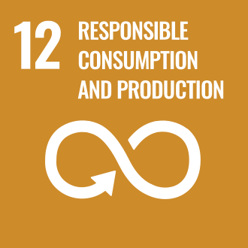
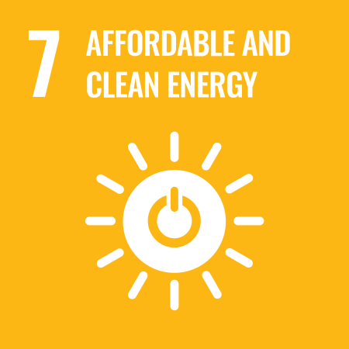
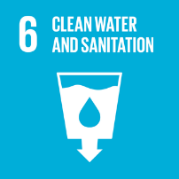



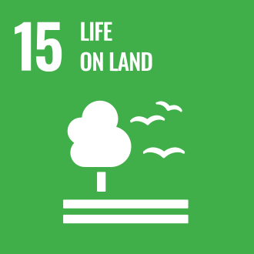

Review Mechanism
This Environmental Sustainability Roadmap shall be reviewed at least once every year, or earlier if required due to changes in applicable legal and regulatory requirements, business operations, environmental risks, stakeholder expectations, or organizational objectives. The review shall ensure that the policy remains relevant, effective, and aligned with the Company's strategic sustainability goals and environmental commitments.
The review shall be coordinated by the Environment, Health & Safety (EHS) Department and approved by the Management. Any revisions arising from the review shall be communicated to all relevant employees and stakeholders, and appropriate actions shall be implemented to support the continual improvement of the Company's Environmental Management System and environmental performance.
Authorized by:

Legal & Compliance Head
DRT – Anthea Aroma Chemicals Pvt. Ltd.

Employee Acknowledgement Form
I acknowledge that I have read, understood, and agree to comply with the Environmental Sustainability Roadmap of DRT-Anthea Aroma Chemicals Pvt. Ltd. I understand my responsibility to support the Company's environmental commitments by adhering to applicable environmental procedures, using natural resources responsibly, preventing pollution, reporting environmental incidents or concerns, and contributing to the continual improvement of the Company's environmental performance.
I further acknowledge that compliance with this policy is a condition of my employment and that I am committed to conducting my duties in accordance with the Company's environmental objectives, applicable legal and regulatory requirements, and established Environmental Management System.
Employee Name: _______________________________________
Employee ID: _________________________________________
Department: __________________________________________
Designation: _________________________________________
Signature: ___________________________________________
Date: ________________________________________________

